Home and Community Care Support Services Quality Framework  Home and Community Care Support Services is committed to always improving our services.  The organization’s Quality Framework is used across all 14 Home and Community Care Support Services to drive patient care and service delivery.  Over 900 individuals representing staff, service providers, patient and family advisors, and other partners were engaged in its development.  The framework is a blueprint, or map, for improving patient care, caregiver and staff experience. It helps guide us in the right direction when problem-solving, planning and creating an organizational culture of continuous quality improvement.  Watch this video to learn more about our framework |  |    | 
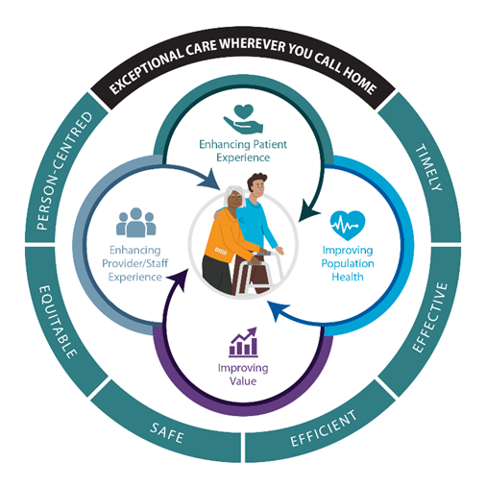
Home and Community Care Support Services’ approach to ensuring quality patient care is represented by the following visual.

The center of the circle is a patient and a caregiver – because they are at the centre of everything we do.

Around the patient and the caregiver are four important factors that define what quality is, and sets the approach for holding ourselves accountable.

The outer circle has our Vision of “Exceptional Care Wherever you Call Home” and includes six dimensions of high-quality health care.

[include alt text of visual for accessibility and link to black and white version]

Read a summary of the Quality Framework

